CASE-BASED REASONING SYSTEM DOCUMENTATION
Geofrey Miguel Erlano & Lance Kirsten Buenaventura
CS0065-AN41
October 3, 2026

Disaster Response Decision Support System (DSS)
Our Case-Based Reasoning (CBR) system stores historical disaster examples and saved classroom scenarios in a local JSON database (disaster_memory.json). Cases represent typhoons, earthquakes, and floods. Each case contains a problem description—disaster type, intensity, location, and proximity hazard—and a solution containing an evacuation strategy, numeric shelter capacity, and categorized resources. Historical context, facility descriptions, and community tips are included when available. The system can also retrieve earthquake records from the USGS API to supplement its search. Responses attached to these online records are classroom templates rather than verified historical response plans.

Explanation of Similarity Method (Retrieve Phase)
The system first filters the available cases to include only those with the same disaster type as the new problem. It then applies weighted scoring:
- Disaster Type: +5 points for the matching type.
- Location: +3 points when the entered location appears in the stored location.
- Proximity Hazard: +2 points when the entered hazard appears in the stored hazard, excluding blank values and “None.”
- Intensity: Up to +5 points, calculated as max(0, 5 − absolute intensity difference).
The case with the highest total score is retrieved. If no case matches the disaster type, the system reports that no suitable case is available instead of reusing a different disaster type.

Adaptation Logic (Reuse, Revise, and Retain Phases)
The system copies the retrieved solution and applies rules to adapt it without changing the original case:
- Intensity Scaling: When the new intensity exceeds the retrieved case’s intensity by more than 1.0, shelter capacity increases by 50%, rounded up to a whole number. Otherwise, capacity remains unchanged. The original and recommended capacities are displayed. This percentage is a classroom project rule.
- Proximity Hazard Adaptation: The system adds predefined recommendations and resources based on the entered hazard. For example, coastal scenarios receive coastal-response recommendations, while mountain scenarios receive landslide-related guidance and clearing equipment. Community tips also depend on the disaster type and hazard.
- User Review and Revision: The user can accept the recommended shelter capacity or enter a revised positive whole number.
- Retention: If the user chooses to save, the system stores the new scenario and reviewed solution in the JSON database, confirms the final capacity, and displays the updated case list.

Screenshots of Program Execution

Figure 1. New Problem and Case Retrieval
The system retrieves a similar typhoon case with a similarity score of 13.00.
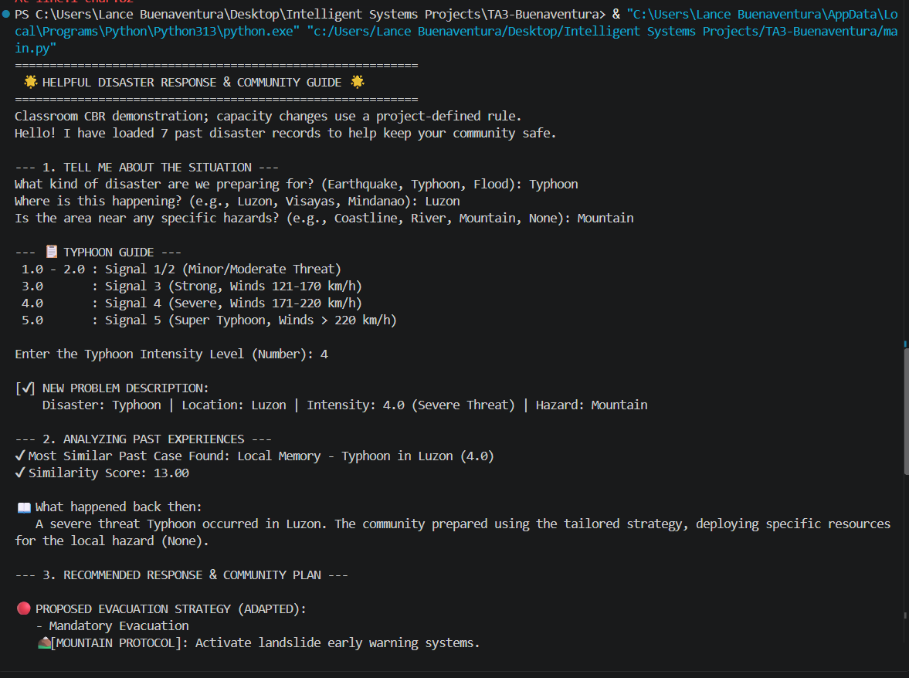
Figure 2. Shelter Capacity Revision and Saving
The user revises shelter capacity from 5,000 to 12,500 beds, and the system saves the reviewed plan.
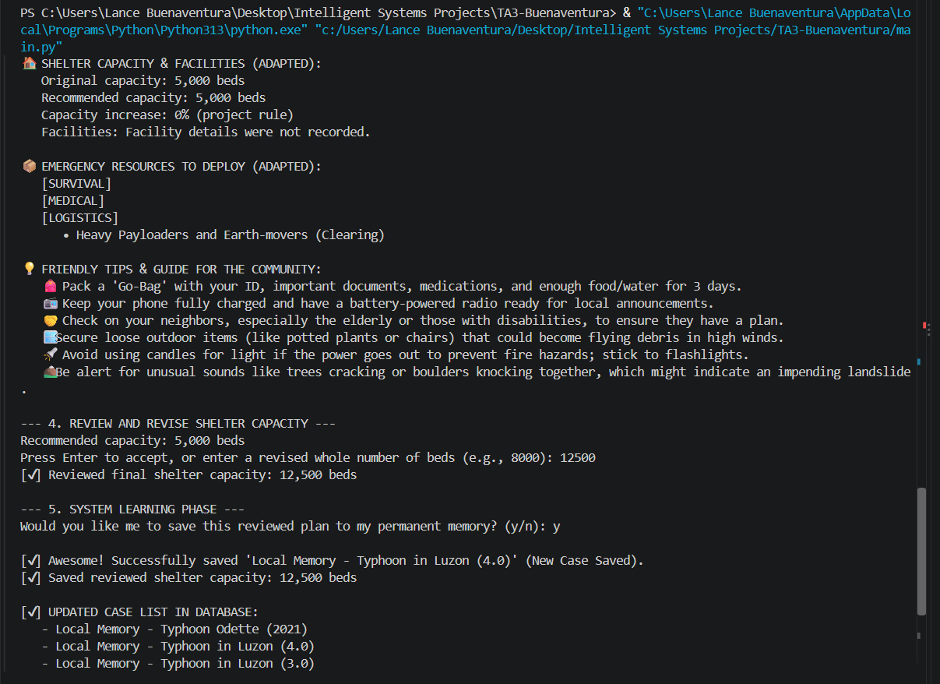

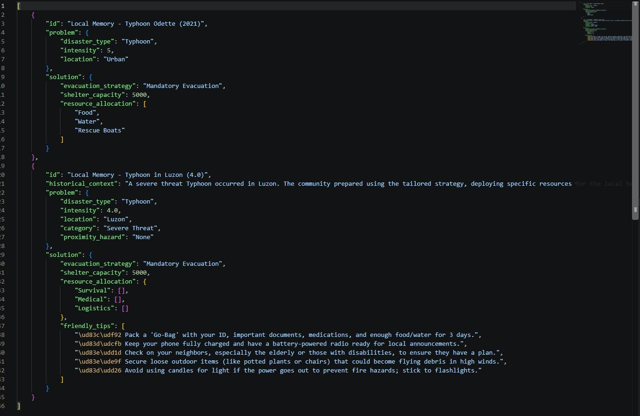
Figure 3. Updated Case Base
The updated case list includes the newly saved scenario.

Pair Reflection
- What each partner contributed
- Erlano developed the main program flow and the interface for entering disaster details, such as type, location, intensity, and nearby hazards. They implemented the weighted similarity scoring used to compare scenarios and retrieve relevant past cases. They also connected the system to the USGS API to include online earthquake records in the search.
- Lance worked on the JSON database and improved the shelter-capacity calculation, including displaying the original and recommended values for easier comparison. They added a review step so users could accept or revise the capacity before saving the plan for future use. They also helped test the retrieval and saving processes and resolve compatibility issues with older records while preserving existing resources.

What challenges you encountered
- Our main challenge was fine-tuning the weighted scoring system so the AI wouldn't accidentally match an earthquake with a typhoon just because they shared the same intensity level. Additionally, we had to implement deep-copy functions to ensure the AI could adapt complex resource lists without permanently overwriting or corrupting the original historical cases.

What you learned about CBR
- This project taught us that Case-Based Reasoning is incredibly efficient for dynamic environments like disaster response because it mimics how human experts adapt past knowledge to fit new constraints. Most importantly, we saw firsthand the power of the "Retain" phase; by permanently saving our adapted solutions to a local file, the system actively learns and improves its own reasoning without requiring us to write new code.

